Department of Special Education
Graduate College of Education

Education Specialist and Masters Degree Program in Early Childhood Special Education (ECSE)

Program Handbook
2022

Introduction

Welcome to the Early Childhood Special Education Program at San Francisco State University!

This program handbook includes our philosophy, course and field experience information, and other useful information and resources. The handbook is designed to supplement other university and departmental materials to assist students in completing their programs successfully.

Sincerely,

ECSE Faculty and Instructor Team

Table of Contents

- ECSE Program Faculty Contact Information ……………… | 4
- ECSE Program Philosophy ………………………………….. | 5
- Preliminary Specialist Credential in ECSE ………………… | 6
- Course Sequence …………………………………………. | 6
- Field Experience Overview ………………………………. | 7
i) Criteria for Selection of Field Experience Sites ……… | 8
ii) Responsibilities of Student Teacher ………………….. | 9
iii) Responsibilities of the Cooperating Teacher……… | 10
iv. Cultivating a Success Mentorship for Student Teachers | 11
v) Responsibilities of University Supervisor | 15
vi) Field Experience Assessment | 16
- Intern Credential | 17
- Masters of Arts in Special Education, Program Area ECSE: Program Overview | 18
- Course Sequence | 18
- Culminating Experience Guidelines | 19
6) Student Conduct Policy | 23
Appendices | 26
Field Experience Assessment Forms: Student Teaching Observation Form; Mid and Post Student Teaching Evaluations; Student Teaching Portfolio Rubrics; Individual Development Plans

Early Childhood Special Education Program Faculty Information

Maryssa Kucskar Mitsch  Assistant Professor  Dr. Mitsch is an Assistant Professor of Early Childhood Special Education in the Department of Special Education. Her primary teaching responsibilities includes courses in early intervention, assessment of young children at-risk and with disabilities, and family systems. Dr. Mitsch’s primary research interests focus on inclusive practices, social skills interventions for young children with disabilities, implementation of evidence-based practices, and strategies for effective professional development. | Burk Hall 204  mmitsch@sfsu.edu  415-338-3430
Summer Tsai-hsing Hsia  Associate Professor  Dr. Hsia is an Associate Professor and coordinates the Intern Program. Her primary responsibilities include teaching courses in the area of early childhood special education, supervising student teachers, chairing the master’s degree students’ projects, and mentoring students in the Joint Doctoral Program. | Burk Hall 148  summerh@sfsu.edu  415-338-2502
Amber Friesen  Associate Professor  Dr. Amber Friesen is an Associate Professor is early childhood special education in the Department of Special Education. Her primary teaching responsibilities include courses in family systems and services, and early intervention. Dr. Friesen’s primary research interests focus on supporting young children at-risk or diagnosed with disabilities and their families. Specifically she is interested in promoting inclusive early childhood settings and strong family partnerships. | Burk Hall 201  afriesen@sfsu.edu  415-338-7654

Early Childhood Special Education Program Philosophy

The Early Childhood Special Education (ECSE) program at San Francisco State University is focused on the interdisciplinary preparation of individuals to be able to support the learning and development of young children (birth to age 5) with identified support needs and/or disabilities, and their families, through collaborative and inclusive service delivery/programs. The program is deeply rooted in the belief that:
….every infant and young child, and their family, regardless of ability, to participate in a broad range of activities and contexts as full members of families, communities and society. The desired results of inclusive experiences of children with and without disabilities and their families include a sense of belonging and membership, positive social relationships and friendships, and development and learning to reach their full potential. (DEC & NAEYC, 2009, p.2)
Program courses and fieldwork are designed for individuals to gain knowledge, skills, and dispositions that are reflective of best practices in the field of ECSE. In turn, the program is guided by both Federal and state guidelines to develop competencies (see Appendices), and dedicated efforts are made to ensure the program promotes inclusion, fosters anti-bias and cultural responsive reflection, contextualizes all supports and services within family and community partnerships, and seeds the beginning of leadership and advocacy for our field.
DEC/NAEYC. (2009). Early childhood inclusion: A joint position statement of the Division for Early Childhood (DEC) and the National Association for the Education of Young Children (NAEYC). Chapel Hill: The University of North Carolina, FPG Child Development Institute.

Preliminary Education Specialist Credential in ECSE
Course Sequence

Category I: Core Course

SPED 788 Laws, Ethics, Collaboration, Technology & Instructional Planning (3 units)
SPED 801 Development, Diversity and English-Language Learners (3 units)
H ED 630 Elementary School Health (3 units) *

Category II: Early Childhood Special Education Methods Cluster

SPED 777 Development and Learning of Young Children with Special Needs (3 units)
SPED 779 Family Systems and Services (3 units)
SPED 737 Infant Intervention (3 units)
SPED 738 Preschool Intervention (3 units)
SPED 780 Assessment and Program Evaluation in ECSE Settings(3 units)
SPED 747 Physical Disabilities and Sensory Impairments (3 units)
SPED 774 Positive Behavior Supports (3 units)
SPED 825 Behavior and Instructional Supports: Autism (3 units) or SPED 794 Communication, Socialization and Imagination: Autism (3 units)
SPED 885 Topics in Early Childhood Special Education (3 units)

Category III: Student Teaching

Infant Toddler
SPED 730 Student Teaching Special Education (3 or 9 units)
SPED 729 Student Teaching Workshop – ECSE

Preschool
SPED 730 Student Teaching Special Education (3 or 9 units)
SPED 729 Student Teaching Workshop – ECSE

Additional Requirements

CPR (online course not acceptable) – must cover infant, child and adult

US Constitution Requirement

*See http://www.sfsu.edu/~spedcd/pdf/HEDSubst.pdf for approved substitutions.
Field Experience Overview
Preliminary Education Specialist Credential in ECSE

Individuals enrolled in the Preliminary Education Specialist Credential in ECSE are required to complete two, semester-long student teaching experiences. One semester must be with a program serving infants and toddler (birth through 3) identified with disabilities (SPED 731) for at least 120 hours. Another semester must be with a program serving children 3 through 5 identified with disabilities (SPED 730) for at least 200 hours. Possible settings for student teaching include early intervention home visiting and/or center-based programs serving infants and toddlers, school district programs, Early/Head start centers, and more (see I. Criteria for Selection of Field Experience Site).
Throughout each student teaching experience, the student teacher demonstrates their professionalism and emerging competencies, ideally being a valued member of the program/classroom (see ii. Responsibilities of an ECSE Student Teacher). The student teacher works closely with their assigned cooperating early childhood special educator or interventionist who mentors, models and co-teaches with them (see iii. Responsibilities of the Cooperating ECSE Teacher). In order for this relationship to be successful, time and effort needs to be into cultivating this relationship, establishing trust, and ultimately demonstrating a co-teaching relationship (see iv. Cultivating a Success Mentorship for Student Teachers). The student teacher is assigned a University Supervisor who will observe, support and assess them (see v. Responsibilities of the University Supervisor). At numerous points throughout the student teaching experiences, the student teacher will have opportunities to demonstrate their developing ECSE competencies including a scaffolded, semester-long student teaching portfolio assignment (see vi. Field Experience Assessment).
During the course of both student teaching semesters, the student teacher will also enroll in a Student Teaching Workshop (SPED 729). This seminar facilitates problem-solving, portfolio development, and self-reflection. Upon completion, the student teacher develops an Individual Development Plan (IDP) in preparation to transitioning from student teacher to teacher.
i. Criteria for Selection of Field Experience Sites
We seek to place ECSE student teachers with highly qualified, cooperating teachers who are working as early childhood special educators and interventionists. The following qualifications and skills are used to help identify these individuals.
Minimum Qualifications
- Clear credential (or in progress) in the content area for which mentoring is to be provided. Note that in some cases a credential/graduate level degree in a closely related field may be considered;
- Minimum two (2) full years of accomplished work in a setting that partners young children (birth to age 5) identified with disabilities, and their families.
- Demonstrated ability to build collaborative relationships with colleagues, staff, and families.
- Demonstrated ability to mentor a student and exhibit the necessary interpersonal skills to lead and support student teachers

Strongly Recommended Professional Skills

- Evidence of exemplary ECSE practices that are reflective of competencies and standards that govern the ECSE field. These include but are not limited to DEC Recommended Practices, California ECSE Program Standards, CA ECSE Teacher Performance Expectations (see Appendices)
- Demonstrated commitment to social justice and inclusion including but not limited to children and families with diverse racial and linguistic identities, those facing challenges due to socioeconomic disparities, children facing immigrant youth, LGBTQ, and/or children with diverse support needs or identified disabilities in inclusive settings;
- Growth mindset about children and families – a belief that all students can learn and that families are key partners, regardless of class, race, culture, linguistic background, gender, physical/different abilities;
- Proven commitment to one’s own ongoing professional learning to deepen one’s craft and practice by participating in strategic and intentional PD that translates to positive outcomes for all students

ii. Responsibilities of ECSE Student Teacher
The student teaching experiences are designed to provide hands-on teaching experience with supervision from both the University Supervisor and the Cooperating Teacher. In both an infant/toddler setting (SPED 731) and a preschool setting (SPED 730), the student teacher will have opportunities to observe, participate, and co-teach in a variety of service delivery settings.
To be successful, the student teacher is encouraged to:
- Give priority to student teaching, viewing it as a professional responsibility. Arrive early, dress appropriately following program/classroom procedures (including safety and security policies), and inform both the Cooperating Teacher and the University Supervisor of unavoidable absences.
- Become as much a part of the staff as possible. The student teacher should introduce themselves to team members and join in meetings and social functions when invited. They are encouraged to ask questions, take initiative, and ensure follow through to commitments and plans that have been asked/volunteered to do.
- Get to know the children within the program and classroom. The student teacher has been kindly invited into this setting and has the opportunities to spend time and learn from, and support, these children during this time. A reminder to keep information about children and families confidential.
- Consult on a regular basis with the Cooperating Teacher and University Supervisor, and be open to feedback and support. Communication is a vital part of these relationships whether it is planning observation dates, sharing concerns or needs, and asking for support in different areas.
- Complete all required assignments and reflections that are required as part of student teaching, including the semester-long Student Teaching Portfolio, as a means of demonstrating emerging ECSE competencies (see vi. Field Experience Assignments).
- Attend and participate in the Student Teaching Workshop (SPED 729).
- Continually engage in self-evaluation of teaching performance.
iii. Responsibilities of the Cooperating Teacher
The cooperating teacher plays the instrumental role within a student teaching experience as it is this person that the student teacher will observe, learn, and often emulate in their own practices. Ideally, this relationship between cooperating teacher and student teacher takes the form of a mentorship, apprenticeship, and emerging co-teacher/interventionist team.
To be successful, the Cooperating Teacher is encouraged to:
- Be available to the student teacher at all times when the student teacher is at the school/program; view the student teacher as an apprentice to your work.
- Strive to get to know the student teacher and establish a relationship of trust and communication (For ideas on how to do this, see iv. Cultivating a Successful mentorship for Student Teachers).
- Establish formal weekly meeting(s) with the student teacher in addition to ongoing daily communication, at which collaborative responsibilities for positive behavior supports, and the design and delivery of instruction/intervention are developed, refined, executed, and analyzed for improvement and learning.
- Include the student teacher in authentic participation in the classroom/program, and broader community to appreciate schooling as a whole community effort, e.g. IEPs, staff/grade level/department meetings, etc.
- Share appropriate background, assessments and other data about students to support student teacher’s development of instruction informed by multiple data points.
- Observe student teacher’s instructional practice regularly and provide constructive feedback that activates and nurtures student teacher’s reflective stance
- Maintain proactive, ongoing communication with University Supervisor about the student teacher’s progress and goals to take over some instruction/ interventions. Address any concerns or questions with the University Supervisor promptly and with the willingness to work together to support the student teacher in gaining needed competencies.

iv. Cultivating a Successful Mentorship for Student Teachers
As a Cooperating Teacher hosting an Early Childhood Special Education student teacher, the hope is to share planning, teaching, and assessment responsibilities rather than keeping them at bay or unloading all the responsibilities on them. Ideally, the experience throughout the time is scaffolded in which a student teacher first learns through observation, then begins to take on more and more responsibility, and finally is able to demonstrate co-teaching and independent teaching abilities.

The following prompts are tools that may be useful in establishing a positive mentorship for student teachers.

Getting to Know Each Other Activities/Training Activities

These activities will help the Cooperating Teacher and the Student Teacher get to know each other, build rapport, and facilitate an effective co-teaching relationship!

- Partner Interview

From the list below, select 2-3 questions you think are the most interesting and will likely prompt a rich discussion. Think about your own answers to these questions, then share with your partner:

  - What did you do that you are most proud of during these past months?
  - What was your biggest challenge? How did you meet it?
  - What was your biggest disappointment? How did you handle it?
  - What would you do differently if you had a chance to do something again?
  - What did you find to be most stimulating during the past and caused you to grow the most?
  - What are you looking forward to in the months ahead?
  - What worries you most about the coming months?
  - What would you want to say about your work one year from today
  - What is the hardest time of the day for you?
  - When do you feel rushed?
  - When do you think you need more help?

- Value Words:

From the list of value words shared below, work individually to select up to 8 that you consider to be very important. Base your decision on how important the value is to YOU… TODAY. It does not matter if it is something that you currently possess or do, or something you want to improve on, etc. If it is very important, choose it! There are no right or wrong answers.

Now choose the top 4 that are the MOST important to you. Reflect on what these words mean to you and why. Share with your partner! How can these values inform you of the best ways to work with each other?

Clear expectations Visualizing Comfort
Problem solving Power Health Service (to others)
Sincerity Variety Political activism
Wisdom Safety Simplicity
Independence Socializing Adventure
Reading Challenge Self-Improvement
Leisure Punctuality Trustworthiness
Approval Flair Change
Routine Solitude Working under pressure
Competition Arts

Communication is the Key to Great Partnerships. As you have been engaging thus far, what kinds of things have made your conversations successful? Consider facial expressions, physical gestures and posturing, tone of voice, and so on. Chit Chat is like throwing a ball back and forth. It’s pretty easy!

Deeper Communication is like tossing a slippery egg which must be tossed carefully and gently. To tell the truth in a caring manner is not an easy thing to do! Save them up for a long time and hurl them? Throw them hard and fast because you can’t hold on to them? Avoid the person so that you don’t have to toss them at all? Wrap them up in so many layers of expectations and apologies no one is sure whether you have even tossed them? Try to recognize when you have a slippery egg. Be assertive enough to communicate your issues and toss it with care!

- Difficult Conversations:

In a fun way, you will role-play having a difficult conversation. For this activity, the Cooperating Teacher plays the Teacher Candidate and the Teacher Candidate plays the Cooperating Teacher. In your new role, select one conversation topic from those provided next and think about how you can be most effective in communicating the issue at hand.

- For Student Teachers Playing the Cooperating Teacher:
  - You have noticed that your Candidate has come tardy twice now and this is really concerning you.
  - You have noticed that your Candidate has come with an unpleasant body odor and their poor personal hygiene is really concerning you.
  - You have noticed that your Candidate is doing non-classroom related work during the school day (e.g., checking airfare for a vacation, finishing homework, texting, chit-chatting with other adults in the room) and this is really concerning you.
- For the Cooperating Teacher Playing the Student Teacher
  - You have not been receiving specific feedback from your Teacher and this is really bothering you.
  - You have noticed that your Teacher spends the co-planning time working on her own lessons and this is really bothering you.
  - You have noticed that your Teacher his not allowing you to try new ideas or new ways of doing things and this is really bothering you.
  - You have noticed that your Teacher has been stepping in to help you too much, too soon, and this is really bothering you.

- Putting it on the Table

It can be helpful to have a special signal to give each other when there is a difficult issue that needs to be addressed.
- You may choose a fun object to serve as this signal.
- A toy frog set out on the desk can say “let’s jump to an important matter!”
- A bear picture put up on the board can say “its time to grin and bear it”.

Ongoing Collaboration and Mentorship

            - Collaboration: Sharing the Planning

- Decide on a weekly time to plan and reflect together.
- What content to teach?
- What teaching/co-teaching strategies to use?
- Who will lead the different parts of the lesson?
- How will student learning be assessed?
- What materials and resources are needed? Who is responsible for gathering what?

            - Collaboration: Sharing the Instruction

- Share leadership in the classroom.
- Work with all students and classroom staff.
- Use a variety of co-teaching strategies.
- Let your students and staff see you as equal partners.
- Manage the classroom together.
- Make changes as needed during a lesson. Decide on a code phrase the two of you can say to pause or change a lesson when it is urgently needed.
  - When the CT needs to step in without embarrassing the Teacher Candidate.
  - When the Teacher Candidate needs the CT to step in and help, without losing the student/staff respect.
  - When you need to discuss something that cannot wait.

            - Collaboration: Sharing the Assessment

- Both participate in the assessment of students.
- Share the workload of daily grading/data collection and ideas/ways to communicate this info to parents, specialists, staff, administration.
- Both participate in using assessment results to inform subsequent instruction.

            - Collaboration…means both of you!

- Contribute ideas from the very beginning of the Directed Teaching experience.
- Engage with students and assist in their learning from the first day to the last day.
- Participate in leadership roles in planning, instruction, assessment and staff coordination.
- Work together to demonstrate competencies.
- Have opportunities to teach alone.

(Note: Content above adapted from St. Cloud University, Minnesota & California State University – Fullerton)

v. Responsibilities and Roles of University Supervisor
The University Supervisor plays a critical role in supporting student teachers as you facilitate reflection and problem-solving within field-based observations, craft feedback on their emerging ECSE competencies through their practice and work in their student teaching portfolio, and often are a source of support and confidence building as the student teacher gets ready to transition to teacher. Further, the University Supervisor plays an important role as a bridge between the SFSU ECSE program and the schools/programs.

To be successful, the University Supervisor is encouraged to:

- Maintain on-going communication with the student teacher, cooperating teacher, and university faculty throughout the student teaching experience.
- Facilitate at least 4 observation visits (usually an 1 hour in length) to the site to see the student teacher demonstrate their emerging ECSE competencies. This may include times where the student teacher is leading individual or small group instruction, facilitating a whole classroom activity, conducting an assessment, etc. Ideally different observation visits would allow for different types of teaching contexts to be seen. Note that it may be necessary to visit a student teacher more offer if further support is needed.
- During observation visits, Introduce yourself to the principal/director and inform the principal’s office when supervising in a school. Follow school procedures for signing in.
- Provide ongoing feedback to the student teacher through the following ways (see vi. Field Experience Assessment for more information):
  - After each observation visits using the Student teacher Observation Form to guide your reflections and ideas for the student teacher
  - Provide ongoing feedback to the student teacher regarding emerging ECSE competencies using the mid and final Student Teaching Rubrics to foster communication and goal-making.
  - Provide ongoing feedback to the student teacher through scaffolding the student teaching portfolio and providing feedback at each section to assist the student teaching in their emerging
- Promptly connect with University ECSE faculty is concerns or issues arise with the cooperating teacher, program/school site, student teacher, etc. ECSE competencies (see vi. Field Experience Assessment)
vi. Field Experience Assessment
Providing comprehensive and ongoing feedback to the student teacher is an essential component of the student teaching experience. These measures are completed within a growth mindset, giving the student teacher specific examples of when ECSE competencies are observed in the field or demonstrated in their Student Teaching Portfolio, and by facilitating self-reflection of those still emerging. The following Field Experience Assessments are used within Student Teaching Experiences (see Appendices for blank samples):
- Student Teaching Observation Form: This form is completed after each observation and it includes a summary of what was observed and then feedback/considerations for the student teacher to reflect upon. Prompts for the University Supervisor to use on this form include utilizing the California Teacher Preparation Expectations as well as the Linked System Approach (Johnson, Rahn & Bricker, 2015), the approach utilized in the Student Teaching Portfolio.
- Mid- and Final Student Teacher Evaluation: Developing ECSE Competencies and Disposition. At both the middle and end of the student teacher semester, the University Supervisor completes an evaluation on the developing ECSE competencies (e.g. evaluation/ assessment, intervention/instruction, documentation/report writing) as well as the professional and personal qualitied of the student teacher being observed.
- Student Teaching Portfolio. Throughout the student teaching experience, the student teacher completes a detailed and comprehensive portfolio in which they partner with their cooperating teacher, a young child in the setting they are completing the experience, and the child’s family. With the University Supervisor providing feedback, the student engages in the Linked Systems Approach (Johnson, Rahn & Bricker, 2015) in which they get to know the child and family including conducting an assessment, develop goals and objectives for the child, plan and implement activity-based interventions, and monitor process. Through each step, the student teacher is asked to self-reflect.
- Individual Development Plan. Within the required, corresponding Student Teaching seminar (SPED 729) that student teachers take as they complete both semesters of student teacher, they complete an individual development plan. The purpose of this is to support their transition from student teacher to teacher and to be used by the new teacher’s induction program to help guide the induction experience. The plan prompts them to set professional development target areas, develop a plan of action, and then providing evaluation evidence.

Intern Credential

The Intern Credential is a temporary teaching license issued by the Commission on Teacher Credentialing to those who are in the process of completing the requirements for the Preliminary Credential. Eligibility criteria for the intern credential include passing the CTC Basic Skills requirement (e.g., CBEST), enrolled in a minimum of 6 units of ECSE credential courses per semester, and having an official position offer as the teacher of record from a school or program. See the Intern Credential webpage for specific requirements for the application of the Intern Credential.

Course Requirements
Master of Art in Special Education, Program Area ECSE

Required Coursework
SPED 788 Laws, Ethics, Collaboration, Technology & Instructional Planning (3 units)
ISED 797 Educational Research (3 units)
SPED 779 Family Systems and Services (3 units)
SPED 777 Development and Learning of Young Children with Special Needs (3 units)
SPED 737 Infant Intervention (3 units)
SPED 738 Preschool Intervention (3 units)
SPED 780 Assessment and Program Evaluation in ECSE Settings (3 units)
SPED 885: Topics in ECSE (Leadership and Collaboration) (3 units)

Culminating Experience Options

Option I | Two graduate level elective courses (one of which can be a course required by the Credential Program) and Comprehensive Exam (6 units total)
Option II | An elective graduate seminar (which can be a course required by the Credential Program) and SPED 894 Creative Work Project (6 units total )
Option III | SPED 881: Advanced Research Seminar in Special Education and SPED 898 master’s Thesis with Oral Defense of Thesis (6 units total)

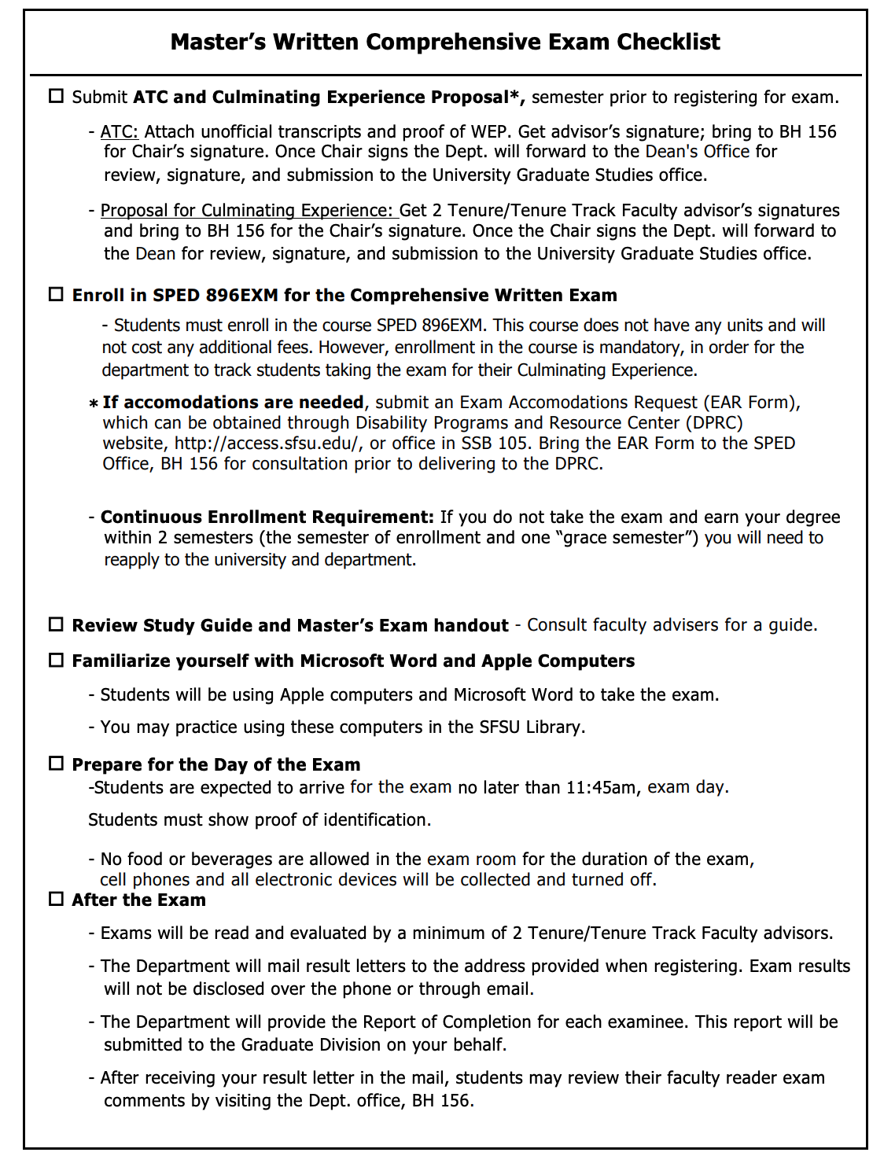

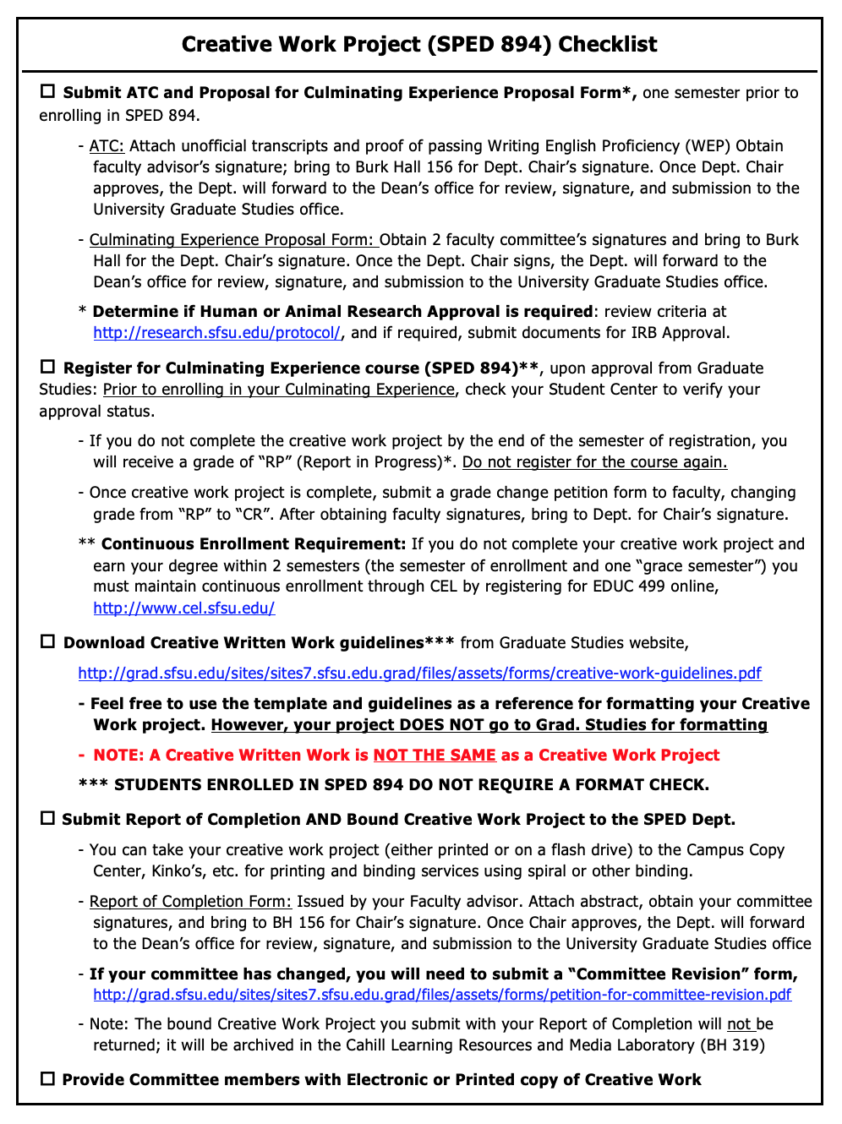

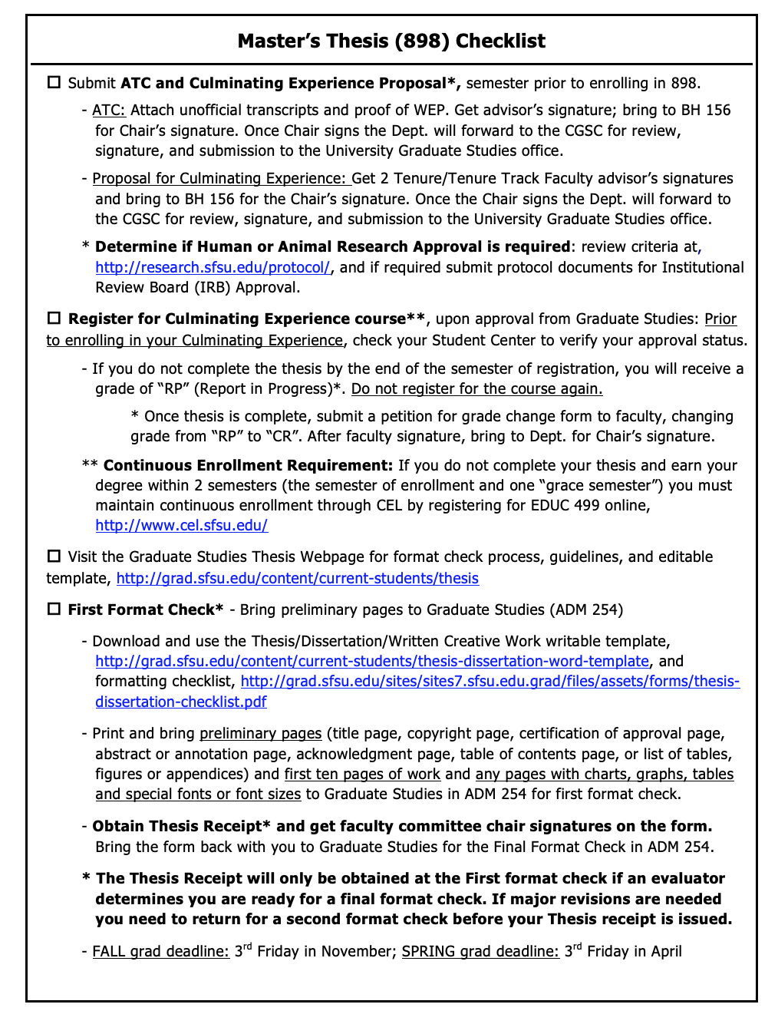

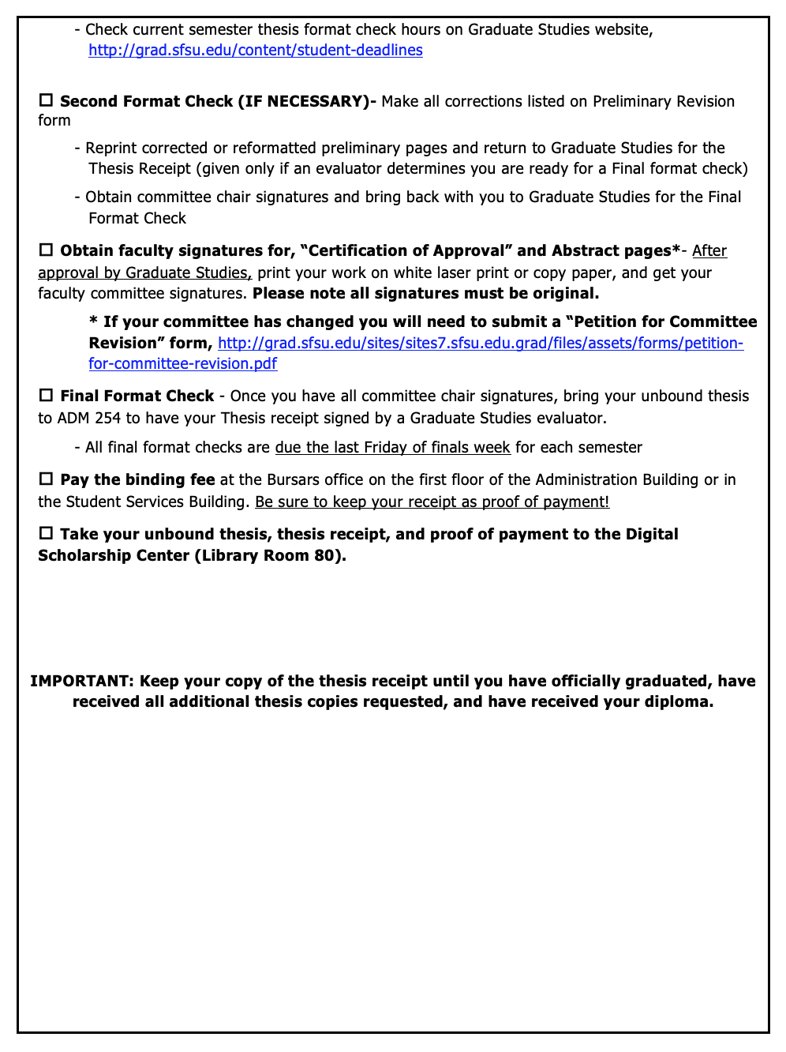

STUDENT CONDUCT POLICY
(Adapted from the Program Handbook, Extensive Support Needs Program, Department of Special Education, SFSU)

Ethical Principles

Confidentiality and Professional Language Use

- Participants in this course must be committed to a code of professional ethics by ensuring confidentiality is protected for all individuals identified with disabilities and their families. To ensure privacy and respect for these individuals, students are asked to use pseudonyms in reference to all real persons and places in written materials (in paper and digital form) and/or to use only first names in class discussions and presentations.
- Students will limit discussions of students, teachers, and schools to members of the ECSE program (i.e., discussions should not occur within earshot of the public in places such as elevators, hallways, etc.).
- Students are responsible for obtaining appropriate permission from schools/programs and/or families to share photographs and videotapes of individuals in class.
- Students are expected to communicate about disability in a manner that maintains integrity (worth and dignity) of all individuals as human beings. Authors are encouraged to use terms and descriptions that both honor and explain person-first and identity-first perspectives. Language should be selected that reflects the expressed preference of people with disabilities regarding their identification. More information on writing with bias-free language can be found here - https://apastyle.apa.org/style-grammar-guidelines/bias-free-language/

Classroom Community and Respect for Others

- “The classroom is a special environment in which students and faculty come together to promote learning and growth. It is essential to this learning environment that respect for the rights of others seeking to learn, respect for the professionalism of the instructor, and the general goals of academic freedom are maintained. Differences of viewpoint or concerns should be expressed in terms which are supportive of the learning process, creating an environment in which students and faculty may learn to reason with clarity and compassion, to share of themselves without losing their identities, and to develop an understanding of the community in which they live. Student conduct which disrupts the learning process shall not be tolerated and may lead to disciplinary action and/or removal from class.” (Cited from Course Syllabus Self-Checklist, Department of Counseling and Special Education, CSU, Fresno)
- Students and faculty will maintain a classroom atmosphere conducive to learning.
- Students and faculty will treat young students, their families and teachers with respect and dignity both in their presence and in discussions with other members of the faculty and educational team.
- Students and faculty will interact with all members of the program, including young students, families, and classroom teachers in a considerate and cooperative manner.
- Students will judge colleagues fairly and attempt to resolve conflicts in a manner that respects the dignity of every person involved. (Adapted from Student Handbook, Department of Physical Therapy, SFSU)

Professional Behavior

Students enrolled in the Early Childhood Special Education Program understand and accept the importance of professional behavior; ethical standards; honesty; commitment to learning; good interpersonal communication skills; respect for classmates, faculty, classroom teachers and guest speakers; effective use of time and resources; constructive integration of feedback; problem solving; critical thinking; and stress management. These professional behaviors will be emphasized and expected of all students throughout their graduate studies in the SFSU classroom and local schools. (Adapted from Student Handbook, Physical Therapy Program, SFSU)
Students must meet expectations at the given state of their program in the following dispositional areas:

- Demonstrates commitment to understanding diversity
- Demonstrates commitment to enacting the belief that all children can learn and commitment to ensuring their success
- Demonstrates commitment to engaging in personal and professional behaviors that promote self-growth
- Demonstrates commitment to developing interpersonal behaviors that promote and foster collaboration
- Demonstrates professional conduct and ethical behavior suitable to the profession

General professional conduct expected of students include:

- Demonstrates a receptive attitude towards suggestions, feedback and constructive criticism.
- Uses suggestions to make appropriate changes in performance and/or behavior.
- Uses discretion when discussing confidential information.
- Demonstrates flexibility in accommodating to unforeseen conditions or circumstances.
- Offers assistance to others when appropriate.
- Conveys appropriate self-confidence through verbal and nonverbal behavior.
- Recognizes own limitations by asking for guidance and assistance when needed.
- Demonstrates initiative to increase skills and knowledge by using appropriate resources.
- Manages personal affairs in a manner that does not interfere with professional responsibilities.
- Uses appropriate verbal and nonverbal communication skills with others.
- Demonstrates respect, courtesy, and consideration for the rights and dignity of others.
- Maintains a professional appearance and demeanor.
- Manages and prioritizes tasks to meet responsibilities.
- Accepts responsibility for personal mistakes and does not blame others or continually offer excuses. (Cited from Student Handbook, Physical Therapy Program, SFSU)

If the student fails to meet expectations and demonstrates only minimal accomplishment in a given dispositional/behavioral area (as indicated by University and School District classroom observations), substantial further work is needed and must be communicated to the Program Coordinator. If a student displays any unprofessional behaviors, s/he will be at risk of dismissal from the program, independent from grades. The achievement of professionalism is as important as maintaining high academic performance.

Appendices

Student Teaching Observation Form
Student Name:
University Supervisor:
Setting:
Date/ Time:

Summary of Observation
This will likely include a summary of what the University Supervisor observed during their time in the classroom/program/home. This may include the sequence of activities seen, the type of interactions observed, the actions/communication of the children/other adults in the setting, etc.

Student Teaching Observation Form

Supporting Ideas and Considerations
This is an opportunity to provide specific examples of interactions/instruction where the University Supervisor observed the student teacher exhibiting high-quality interactions/instruction. Further, this is a time where questions or ideas can be posed to further the student teachers’ self-reflection, problem solving and/or competence development. Prompts and ideas can be found on page 3 of this document.

Student Teaching Observation Form

Possible Prompts Structures to Provide Feedback to Student Teachers

Consider pinpointing examples or promoting reflection that follow the Teacher Performance Expectations for ECSE in California. This could include ways in which they are developing or achieving the following:

- Engaging and Supporting Young Children in Learning

- Creating and Maintaining Effective Environments for Young Children’s Learning

- Understanding and Organizing Subject Matter for Young Children’s Learning

- Planning Instruction and Intervention, and Designing Learning Experiences for All Young Children

- Assessing Young Children’s learning and Development

- Developing as a Professional Educator

Further, you may choose to provide specific praise or reflection on the focus child(ren) that the student teacher is focused on within their student teacher portfolio. As the student teacher completed this semester-long process, they should show growing competencies in the different components of the Linked Systems Approach (Johnson, Rahn & Bricker, 2015)

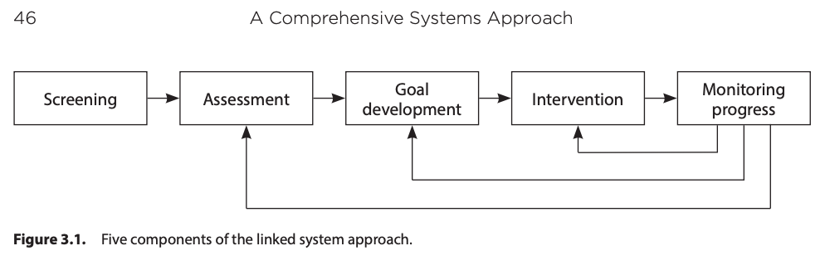

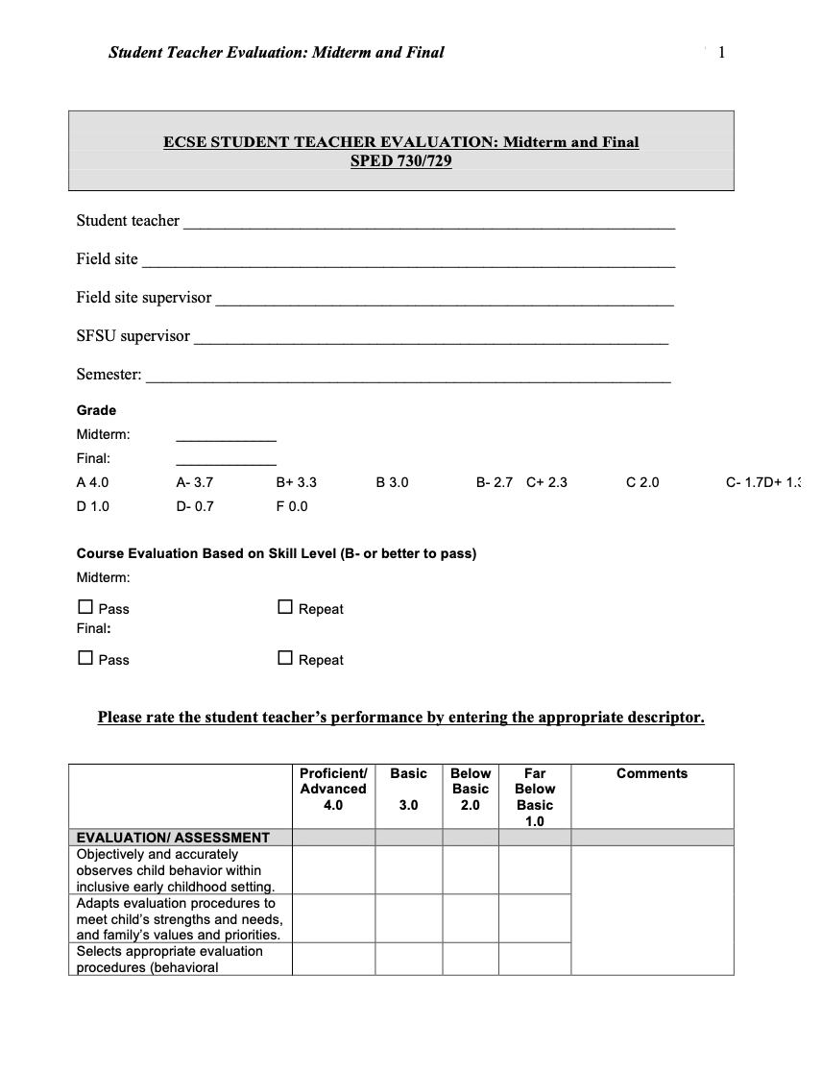

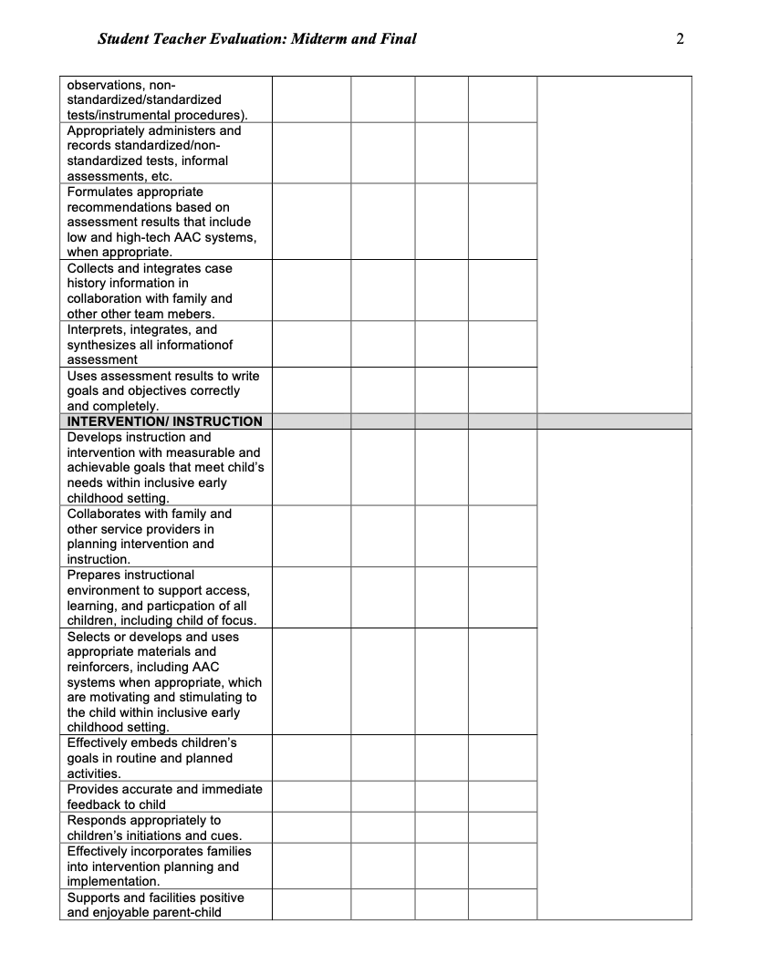

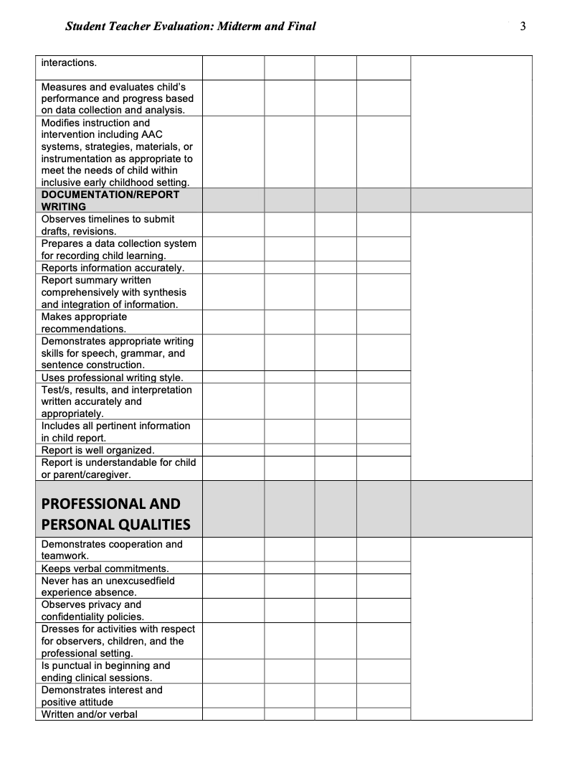

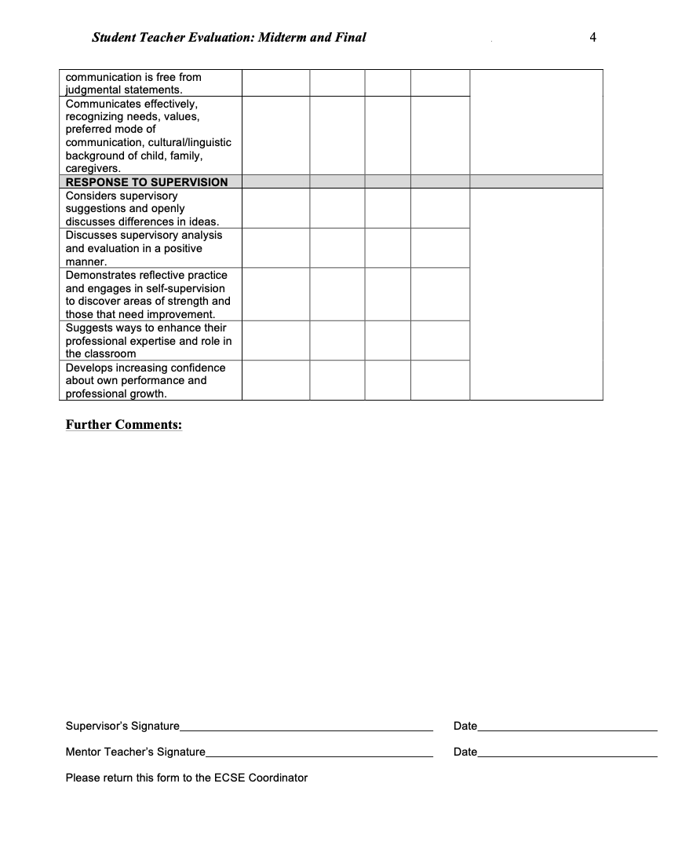

Student Teaching Portfolio Description
Description: This portfolio demonstrates your competency conducting curriculum-based assessment, program planning, and progress evaluation for one child aged birth to five. The portfolio represents some of the critical elements required to plan intervention goals/objectives, document intervention strategies and modifications, and evaluate child progress towards individualized intervention goals/objectives. You will complete one Intervention Portfolio for each semester you are enrolled in Student Teaching. Assignments completed in coursework prior to Student Teaching are suggested references for completing each section of the Intervention Portfolio. There are eight sections in the portfolio for Preschool Student Teaching and ten sections for the Infant Student teaching.
Adjustments to the portfolio or exceptions should be discussed and approved by your University Supervisor based on the specific opportunities at your site. It is important to be able to demonstrate all skills implemented in your site to pass student teaching and upon completion of the program.
Directions: Your supervisor will provide information about how you will submit sections of your completed Intervention Portfolio. You may be asked to submit a 3-ring notebook or a CD, post materials to a website, or send documents via email. Each section should have a brief (no more than 3 pages) reflection. See the portfolio evaluation form for reflection questions. Reflections should be succinct. Your supervisor will complete an evaluation of each section of the Intervention Portfolio.
Writing a Good Reflection: Reflection questions can be found in the portfolio and should be answered completely and thoughtfully. When determining how to fully meet this reflective practice competency, look at what the evidence-based practices may be for that area of competency. For example: You may have limited access to the families with whom you work or to child files. When writing your reflection about gathering information about the family, consider how you might have had a different relationship or how you could improve communication. Talk to your Field Site Supervisor and ask him/her why they work with that particular family that way or what obstacles they have had to overcome to maintain a relationship with a particular family. Draw from your coursework to help you determine a better course of action and reflect on what you have learned.
Each site will provide unique opportunities for you and flexibility is important. Preschool programs may have more opportunities for large group instruction than infant toddler programs but explore what kind of activities fit the population you are serving. Reflect on how your site addresses the needs of the children with whom you are working and incorporate your thoughts based on knowledge and experience of what you could do to implement strategies into your own program. In your reflection please include thoughts on how you could incorporate the relevant strategies with all of the children and families with whom you are working not just your focus child. In accordance with the English Learner Authorization please reflect on how you may include a child or children who are an English Language Learners especially if your focus child is not an ELL.
Selecting a Focus Child: For the purpose of this portfolio you will need to select a child and family as the focus of your intervention. The Field Site Supervisor should give input and ultimately approve selection of the child and family. You need to select a child and family you feel you will have enough material and access to in order to complete all required documents in the portfolio. Ideally this should be a child that you think you can learn from and one who is from a population with which you have less experience. For example, if you have extensive experience with children with Autism, choose a child who does not have an Autism Spectrum Disorder. Additionally, you should select a child whose parents you will have access to during your student teaching experience. Using strategies for partnering with families is a critical part of intervention competency; selecting a family who is comfortable working with Student Teacher will be important as you provide intervention during the semester and complete your portfolio.
Evaluation: The evaluation method, criteria and ratings are listed on the following pages. The following pages are a guide to help the Student Teacher complete the components of the Intervention Portfolio. The following criteria are used to evaluate each section of the Intervention Portfolio. You must receive a 4 or 5 rating on each section in order to pass the section. You must pass all sections in order to receive credit for Student Teaching and receive an ECSE credential and/or Master’s Degree. The ratings are defined below:

1 Missing Competence - section is incomplete and the quality of items is unacceptable. Demonstrates little apparent awareness of either information or skills.
2 Developing Competence - section contains required items but the quality of the item(s) is inadequate and therefore in need of expansion and rewriting. Demonstrates inconsistency in applying knowledge and skills.
3 Growing Competence - section includes required items but the quality of the items requires a minimal amount of work to improve upon the section. Demonstrates an understanding of required information and the ability to apply it most of the time.
4 Initial Competence - section includes required items and the quality of the items meets expected standards. Student is capable of independently applying information and skills but benefits from reminders, reviews and support.
5 Mastery Competence – section includes required items and the quality of the items exceeds expected standards. Student is capable of independently applying information and skills without need for reminders, reviews and support.

1. Letter to Families
Are families whose children I am working with aware of who I am and my role in their child’s program?
 | Section Contains:
Quality Criteria: | Letter to Families
Student teachers: Letter to all families that introduces the Student Teacher including your experience and interests related to working with children, emphasizing you are there to learn and support the classroom teacher. Please do not encourage parents to contact you if they have questions or concerns.
Interns: Write a letter to give to new families that introduces yourself including his/her experience, teaching philosophy, daily schedule, examples of activities, and ways to contact you.
Score: | 1 | 2 | 3 | 4 | 5

2. Intervention Philosophy

Include the following:
- Name
- Site Address
- Telephone/Email
- Educational Background
  - degree,
  - teaching credentials,
  - professional licenses,
  - relevant courses,
  - etc.
- Professional Experiences. Briefly describe experiences you have had working with:
  - children (atypical and normally developing),
  - parents of children,
  - adults with disabilities,
  - etc.
- Career Goals
- Professional Goals for Student Teaching
- Intervention Philosophy
  - 2 pages, double-spaced and typed
  - description of how you believe young children grow and learn (both typically and atypically developing)
  - how this philosophy guides you in various aspects of your practice (e.g., assessment, work with families, etc.)
  - Include names of theorists (e.g., Vygotsky) and specific intervention/teaching methods and/or approaches (e.g., Naturalistic Approaches, Prescriptive Approaches).

 | Section Contains:
Quality Criteria: | Individual Intervention Philosophy
 | Theoretical description of how young children grow and learn (typical and atypical; specific theories are cited)
 | How philosophy guides range of early intervention practices (specific methods/approaches are cited)
Score: | 1 | 2 | 3 | 4 | 5

3. Site, Child and Family Description
Who is the child I’ve selected for this Portfolio? Who are the child’s family members? Which program is serving the child and family? Do I have permission from appropriate sources to perform the requirements of the portfolio with my focus child?

 |  | Section Contains:
 | Quality Criteria: | Description of Site
 |  | Includes a description of program philosophy, mission and goals.
 |  | Provides a general description of children and families served by program.
 |  | Describe the social and physical environment, including furniture arrangement, toys and instructional materials, adult-child ratio, daily schedule of program activities, etc.
 |  | Includes visual representation of program space used by children and families (e.g. map or pictures of the classroom and/or home environment which are labeled).
 |  | Discuss the advantages and disadvantages of the environment.
 |  | Discuss what changes you would make and why
 |  | Description of Child
 |  | Describes physical characteristics of child (e.g. weight, height, eye/hair color, ethnicity, stature)
 |  | Describes history of child’s involvement with EI or ECSE services including: 1) when and how the child became eligible for services (e.g. brief description of the assessments used to determine child’s eligibility), 2) how long child has been receiving services, (e.g. duration and type of services child and family has received, and 3) type of disability or “at-risk” condition that made child eligible for services.
 |  | Uses objective language to describe child
 |  | Includes factual information that is obtained from child’s file – does not include opinions that lack supporting evidence
 |  | Provides a general, yet personalized picture of child’s development based on child’s interests and strengths.
 |  | Description of Family and Consent Letter
 |  | Describes family constellation (father, mother, siblings, extended family members directly and immediately involved with child).
 |  | Consent Form to obtain permission from the family of your focus child to gather materials in intervention portfolio (consult with Field Site Supervisor)
 |  | Reflection (answer the following questions and add additional comments as appropriate)
 |  | Why is it important to gather information about the child and family and program that serves them?
 |  | How will the information you collected assist you in designing and implementing an intervention plan for your focus child?
 |  | Describe any challenges you encountered in the information gathering process.
Score: |  |  | 1 | 2 | 3 | 4 | 5

4. Child Assessment
What information about the child and family will be necessary to develop an IEP with an interdisciplinary team?
 |  | Section Contains:
 | Quality Criteria: | Child Curriculum-Based Assessment
 |  | Describe the assessment used.
 |  | Assessment is comprehensive (e.g., AEPS, Hawaii Early Learning Profile, etc.).
 |  | Assessment is appropriate for child’s developmental level
 |  | Assessment is appropriate for child’s preferred language(s) and culture
 |  | Assessments were conducted prior to intervention
 |  | Assessment information was primarily obtained by observing the child during routine and planned activities at home and/or in ECSE program. If not, text must accompany the assessment and explain why other methods of collecting information were required.
 |  | Assessment is complete with all items scored.
 |  | Child’s Present Level of Functioning
 |  | Includes narrative summary of child’s present level of functioning in all areas (e.g., cognitive, social-communication, gross motor, fine motor, social and adaptive areas).
 |  | Written using family friendly language.
 |  | Reports objective information about the skills the child is currently using and skills that are emerging.
 |  | Includes relevant information about child/family preferred language(s) and the relationship to all developmental areas.
 |  | Includes examples of how and where the child uses the skills reported in the summary and child’s interests related to skills.
 |  | Includes pertinent information provided by parents and other team members about child’s use of skills in various activities and environments.
 |  | Family Concerns
 |  | Concerns, priorities and resources are specifically discussed with family (required for infant/toddler; recommended for preschool). In addition, determine focus for child intervention. Include supporting evidence of discussion (e.g. notes)
 |  | Reflection (answer the following questions and add additional comments as appropriate)
 |  | Were the assessment tools you selected appropriate for the child and family? Would you use different tools next time? If so, why?
 |  | Describe any challenges you encountered in the assessment process
Score: |  |  | 1 | 2 | 3 | 4 | 5

5. Child Goals and Objectives
What skills does the child need to develop? What are the family’s concerns? How would you involve the family to address the concerns and facilitate the child’s development?
 |  | Section Contains:
 | Quality Criteria: | Child Goals and Objectives
 |  | Contains 3 - 5 Long Range Goals in child’s area(s) of need, based on the assessment results in Part V of the requirements.
 |  | Contains 2 - 3 corresponding objectives for each long-term goal, which are arranged in a sequential order leading to the goal. The order takes the form of logical steps, which lead, from most to least difficult and/or most to least support required for the child to accomplish the skill.
 |  | Goals are functional, sensitive to cultural diversity, developmentally appropriate, generalizable.
 |  | Goals and objectives include antecedent, behavior and criteria.
 |  | Goals and objectives are based on assessment results.
 |  | Goals and objectives address or match the family’s concerns.
 |  | Written in family-friendly language.
 |  | Reflection (answer the following questions and add additional comments as appropriate)
 |  | Explain rationale for selecting the goals and objectives.
 |  | Describe any challenges you encountered in writing goals/objectives.
Score: |  |  | 1 | 2 | 3 | 4 | 5

6. Intervention Plans
What intervention will be most helpful for the child to master individual goals and objectives?
 |  | Section Contains:
 | Quality Criteria: | Linked System of Intervention
 |  | Activity Schedules and Activity/Lesson Plans build on one another and link back to Assessment and IEP goals and objectives
 |  | Objective Matrix and Activity Schedule
 |  | Includes all obtainable objectives written for focus child and obtainable objectives for at least 3 other children if applicable.
 |  | Specifies opportunities in which the focus child and at least 3 other children, if applicable, can practice their individual objectives.
 |  | Opportunities are specific such that another teacher could embed goals/objectives into activities.
 |  | Activity/Lesson Plans
 |  | Include 4 activity plans as applicable to your program.
 |  | Activity plans are of varying types (e.g. planned, routine, individual, small group, and large group).
 |  | Activity plans reflect target child’s interest and developmental abilities.
 |  | Target child’s goals and/or objectives from IEP are incorporated in the activity plans with multiple opportunities for child to practice them.
 |  | Group goals and individual goals and objectives of other children, if applicable, are incorporated in the activity plans.
 |  | Activity plans address the following: 1) environmental strategies, 2) special considerations for fostering social interactions, 3) considerations for positioning and handling, 4) specific intervention strategies to embed opportunities for children to practice individual goals and objectives, 5 ) modifications to materials, 6) identification of vocabulary which targets children’s individual communication goals/objectives, 7) modifications and variations, and 8) parental involvement considerations/strategies, 9) English language acquisition and use considerations
 |  | Reflection (answer the following questions and add additional comments as appropriate)
 |  | Rationale for selection of activities
 |  | Were the components of your intervention plan effective in helping your focus child master the skills addressed during instruction?
 |  | What were the strategies you used to encourage peer interaction?
 |  | How would you change your intervention plan if you were to do it again?
 |  | Describe the successes and challenges you encountered while providing intervention.
Score: |  |  | 1 | 2 | 3 | 4 | 5

7. Data Collection
What do I want to know about the child’s progress towards goals/objectives and intervention planned to address them?
 |  | Section Contains:
 | Quality Criteria: | Data Collection Forms
 |  | Data are reflective of goals and objectives selected from assessment and targeted for intervention.
 |  | Form is easily understandable to all team members.
 |  | Contains at least 10 days (or data points) of data on each targeted goal or objective.
 |  | Data reflect criteria contained in the IEP per targeted goal or objective.
 |  | Quantitative/Qualitative data are recorded.
 |  | Data are collected by multiple sources when possible (e.g. parent, team members, program staff).
 |  | Key contains codes on the data collection form that match criteria of goal or objective.
 |  | Graphs Summarizing Data (Optional)
 |  | One graph is included per goal/objective targeted.
 |  | Axes are labeled.
 |  | Key and title of graph are included.
 |  | Graphs are easily understandable by all team members, including family
 |  | Reflection (answer the following questions and add additional comments as appropriate)
 |  | Describe the challenges of collecting data.
 |  | Did your data system give you the data you wanted? If not, how would you modify your system if you were to do it again?
Score: |  |  | 1 | 2 | 3 | 4 | 5

8. Data-Based Decisions
What did the data tell you about the intervention that you implemented for the child?
 |  | Section Contains:
 | Quality Criteria: | Written summary of data and discussion of planning for further instruction
 |  | Significance of data as it pertains to child’s progress or lack thereof towards IEP goals/objectives is discussed.
 |  | Includes discussion of decisions made during intervention process based on data (i.e., was intervention modified based on data collected).
 |  | Identifies areas which need modifying for child’s successful attainment of goals/objectives and child’s overall, continued growth.
 |  | Further instruction suggested is based on data and on child’s interests, strengths and needs, including English learner considerations
Score: |  |  | 1 | 2 | 3 | 4 | 5

9. Organization and Synthesis
Does the portfolio reflect the intervention process by linking each section in a purposeful manner?
 |  | Section Contains:
 | Quality Criteria: | Logical Organization and Clear Synthesis
 |  | Sections are clearly defined and contents of sample are organized.
 |  | Information identifying child and family blocked out throughout sample.
 |  | Well written ---few grammar and spelling errors.
 |  | Clearly documents an understanding of a linked systems approach to Early Intervention/Special Education.
Score: |  |  | 1 | 2 | 3 | 4 | 5

Evaluation Summary |  | Score
1 | Letter to Families
2 | Intervention Philosophy
3 | Site, Child and Family Description
4 | Child and Family Assessment
5 | Child/Family Goals and Objectives
6 | Intervention Plans
7 | Data Collection
8 | Data-Based Decisions
9 | Organization and Synthesis

Averaged Score

Total Score

Department of Special Education
San Francisco State University

Individual Development Plan

Purpose: The standards for institutions sponsoring preliminary teacher preparation programs leading to general education and/or special education teaching credentials require the preliminary program to develop an Individual Development Plan (IDP) for each candidate. This IDP from the preliminary program is intended to be used by the new teacher’s induction program to help guide and inform their induction experience.

The IDP is developed collaboratively with the candidate, the program supervisor, and the district employed supervisor; it must address the adopted Teaching Performance Expectations (TPEs), identifying the areas where the candidate has strengths and recommendations for professional growth goals. In developing the IDP, the preliminary program should consider the variety of available resources. This information can include, but is not limited to, results on performance assessments, course assignments, observations during clinical practice, and other key indicators used by the program (CTC Program Sponsor Alert 18-05).

Name of Special Education Credential Candidate: | Preliminary Credential Area:

Based on your self-assessment of the Teaching Performance Expectations, list 3 strength areas you can build upon during the Teacher Induction Program.

1.

2.

3.

Based on your self-assessment of the Teaching Performance Expectations, list 3 professional growth areas to be developed during the Teacher Induction Program.

1.

2.

3.

For the Program Sponsored-Variable Term Waiver (PS-VTW) holder, below is the list of specific requirements for the Preliminary Credential the candidate was not able to complete before September 1, 2020 due to the COVID-19 pandemic. These requirements must be fulfilled before the candidate is eligible to apply for the Preliminary Credential at SF State.

Program/Credential Requirements | Specific Tasks to be Completed | Deadline for Completion

Credential Candidate Signature: | Date:
Program Faculty Name & Signature: | Date:
Program Coordinator Name & Signature: | Date:
Department Chair Name & Signature: | Date:

